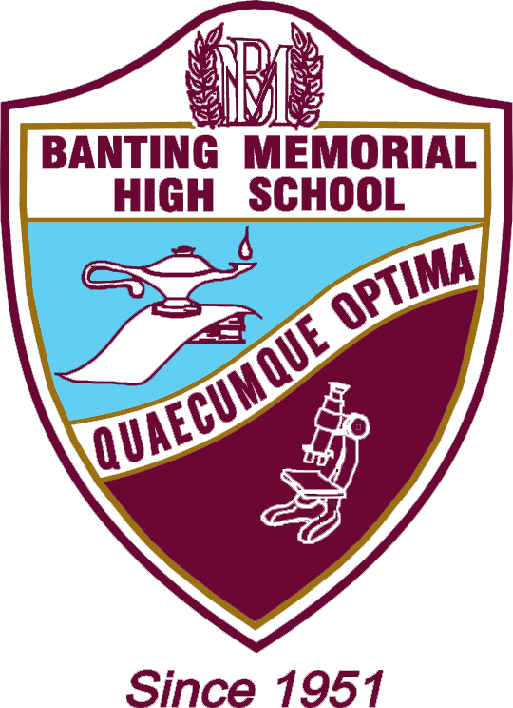

SIMCOE COUNTY DISTRICT SCHOOL BOARD
CONSENT TO RELEASE INFORMATION TO A 3RD PARTY

 | (Full Name – please include both maiden name and current name if applicable) | (Date of birth)
 | (Address) | (Telephone)
I hereby consent and authorize the Simcoe County District School Board to release my transcript, duplicate diploma and/or educational verification documents to:
 | (Name of person picking up the document) | (Relationship)
Last school attended: ____________________________

I also understand that the document(s) will be sealed in an envelope for privacy reasons, and is not to be opened by any other person except the person named on the document. The person indicated above understands they must bring their personal, valid, photo identification, along with this letter in order to pick up the educational verification documents requested.

Name of Student (please print) |  | Signature of student
Name of 3rd Party(please print) |  | Signature of 3rd Party
Date:
For Office Use Only (To be completed by Board Staff)
Staff member authentication of 3rd Party: |  | Valid Photo Identification Shown
 |  | Type of Identification:
Date: |  | Signature:

The information collected on this form is collected in accordance with the Education Act and is subject to the Municipal Freedom of Information and Protection of Privacy Act. Questions about the collection of this personal information should be directed to the Controller, Simcoe County District School Board, 1170 Highway 26, Midhurst, ON L0L 1X0 (705) 734-6363 ext. 11254.

A1456 – FORM 3 REV JUNE 2016

